* createCanvas (width, height)
* Making shapes
  + First x, y variables designate the left coordinate
  + Second x, y variables designate width and height
* Background
  + RGB scale🡪 red, green, blue
    - (0,255) scale
    - Think about mixing those qualities to make colors
    - 255= white and 0=black
    - One number i.e. background (200)= grey is on scale black to white
  + To make red
    - Now takes three variables (Red, Blue, Green)
    - Red= (255, 0, 0)
    - Blue = (0, 255, 0)
    - Green= (0, 0, 255)
  + Look up RGB online for colors
* Coloring shapes
  + Fill () 🡪 inside of shape
  + Stroke () 🡪 outside of shape
    - Can change stroke weight
* 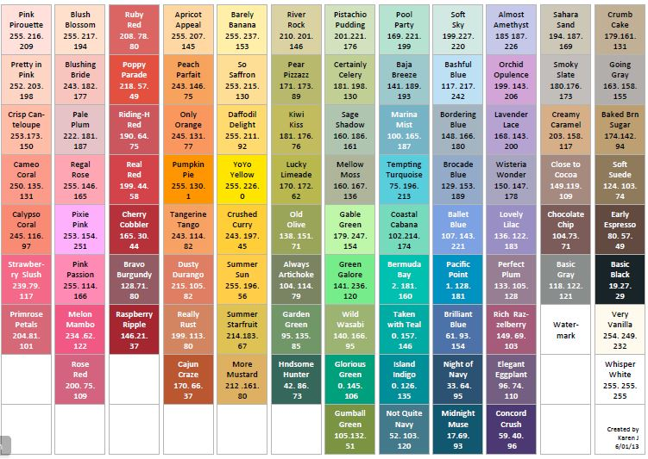
* Note: code reads all the way down; so if you write something in beginning, it will apply it to everything below it
* \*\*// means ignore the lines (for your reference)